Mental Health Illness



**Mental health refers to your emotional and psychological well-being. Having good mental health helps you lead a relatively happy and healthy life. It helps you demonstrate resilience and the ability to cope in the face of life’s adversities.**

**Your mental health can be influenced by a variety of factors, including life events or even your genetics.**

**There are many strategies that can help you establish and keep good mental health. These can include:**

* **keeping a positive attitude**
* **staying physically active**
* **helping other people**
* **getting enough sleep**
* **eating a healthy diet**
* **asking for professional help with your mental health if you need it**
* **socializing with people whom you enjoy spending time with**
* **forming and using effective coping skills to deal with your problems**

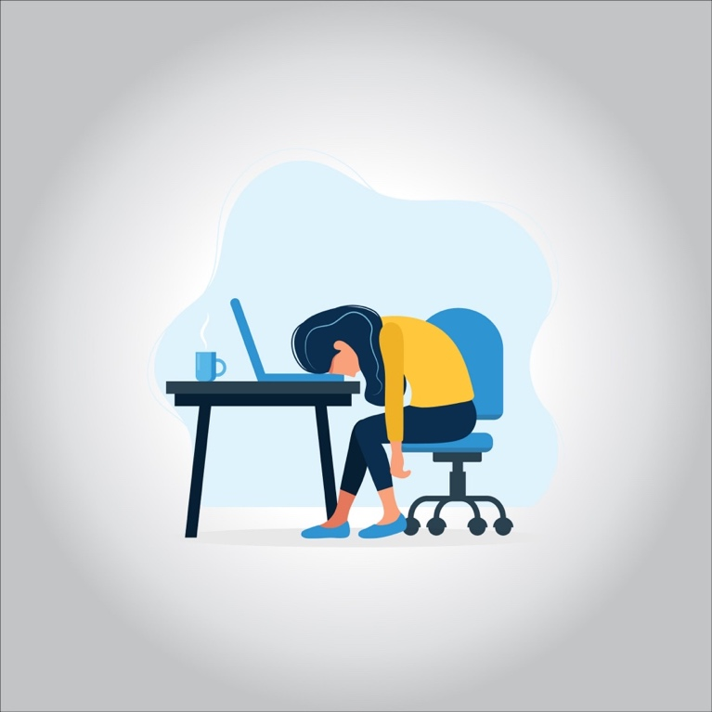

**What is mental illness?**

**A mental illness is a broad term which encompasses a wide variety of conditions which affect the way you feel and think. It can also affect your ability to get through day-to-day life. Mental illnesses can be influenced by several different factors, including:**

* **genetics**
* **environment**
* **daily habits**
* **biology**

**Mental health statistics**

**Mental health issues are common around the world. About one in five adults experience at least one mental illness each year. And around one in five young people ages 13 to 18 experience a mental illness at some point in their lives, too.**

**Although mental illnesses are common, they vary in severity. About one in 25 adults experience a serious mental illness (SMI) each year. A SMI can significantly reduce your ability to carry out daily life. Different groups of people experience SMIs at different rates.**

**According to the National Institute of Mental Health, women are more likely to experience SMI than men. Those ages 18 to 25 are most likely to experience an SMI. People with a mixed-race background are also more likely to experience an SMI than people of other ethnicities.**

**Mental health disorders**

**The Diagnostic and Statistical Manual of Mental Disorders, Fifth Edition (DSM-5) helps mental health professionals diagnose mental illnesses. There are many types of mental health disorders. In fact, almost 300 different conditions are listed in DSM-5.**

**Bipolar disorder**

**Bipolar disorder is a chronic mental. It is characterized by episodes of energetic, manic highs and extreme, sometimes depressive lows.**

**These can affect a person’s energy level and ability to think reasonably. Mood swings caused by bipolar disorder are much more severe than the small ups and downs most people experience on a daily basis.**

**Persistent depressive disorder**

**Persistent depressive disorder is a chronic type of depression. It is also known as dysthymia. While dysthymic depression isn’t intense, it can interfere with daily life. People with this condition experience symptoms for at least two years.**

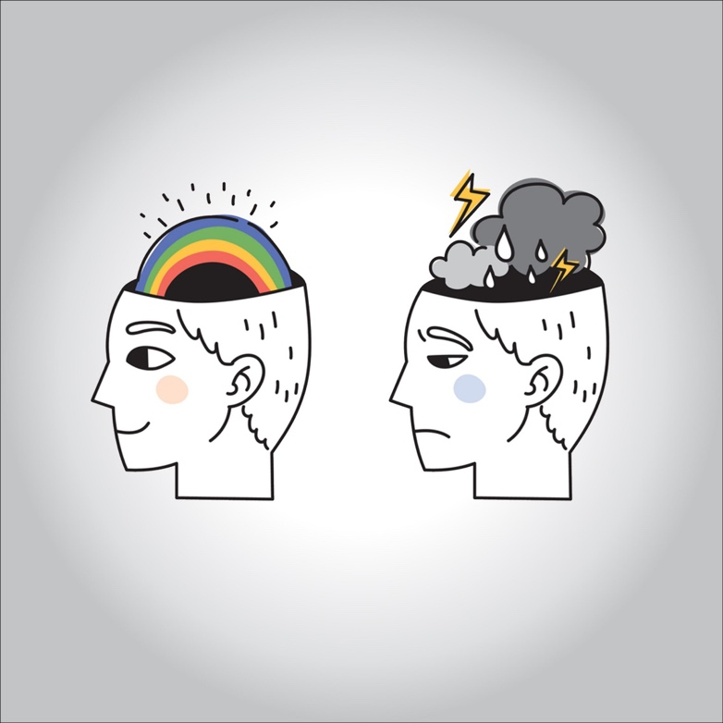

**Generalized anxiety disorder**

**Generalized anxiety disorder (GAD) goes beyond regular everyday anxiety, like being nervous before a presentation. It causes a person to become extremely worried about many things, even when there’s little or no reason to worry.**

**Those with GAD may feel very nervous about getting through the day. They may think things won’t ever work in their favor. Sometimes worrying can keep people with GAD from accomplishing everyday tasks and chores.**

**Major depressive disorder**

**Major depressive disorder (MDD) causes feelings of extreme sadness or hopelessness that lasts for at least two weeks. This condition is also called also called clinical depression.**

**People with MDD may become so upset about their lives that they think about or try to commit suicide.**

**Obsessive-compulsive disorder**

**Obsessive-compulsive disorder (OCD) causes constant and repetitive thoughts, or obsessions. These thoughts happen with unnecessary and unreasonable desires to carry out certain behaviors, or compulsions.**

**Many people with OCD realize that their thoughts and actions are unreasonable, yet they cannot stop them.**

**Post-traumatic stress disorder (PTSD)**

**Post-traumatic stress disorder (PTSD) is a mental illness that’s triggered after experiencing or witnessing a traumatic event. Experiences that can cause PTSD can range from extreme events, like war and national disasters, to verbal or physical abuse.**

**Symptoms of PTSD may include flashbacks or being easily startled.**

**Schizophrenia**

**Schizophrenia impairs a person’s perception of reality and the world around them. It interferes with their connection to other people. It’s a serious condition that needs treatment.**

**They might experience hallucinations, have delusions, and hear voices. These can potentially put them in a dangerous situation if left untreated.**

**Social anxiety disorder**

**Social anxiety disorder, sometimes called social phobia, causes an extreme fear of social situations. People with social anxiety may become very nervous about being around other people. They may feel like they’re being judged.**

**This can make it hard to meet new people and attend social gatherings.**

**Coping with mental illnesses**

**The symptoms of many mental illnesses may get worse if they’re left untreated. Reach out for psychological help if you or someone you know may have a mental illness.**

**If you’re unsure where to start, visit your primary care doctor. They can help with the initial diagnosis and provide a referral to a psychiatrist.**

**It’s important to know that you can still have a full and happy life with a mental illness. Working with a therapist and other members of your mental health team will help you learn healthy ways to manage your condition.**

**Mental health symptoms**

**Each type of mental illness causes its own symptoms. But many share some common characteristics.**

**Common signs of several mental illnesses may include:**

* **not eating enough or overeating**
* **having insomnia or sleeping too much**
* **distancing yourself from other people and favorite activities**
* **feeling fatigue even with enough sleep**
* **feeling numbness or lacking empathy**
* **experiencing unexplainable body pains or achiness**
* **feeling hopeless, helpless or lost**
* **smoking, drinking, or using illicit drugs more than ever before**
* **feeling confusion, forgetfulness, irritability, anger, anxiety, sadness, or fright**
* **constantly fighting or arguing with friends and family**
* **having extreme mood swings that cause relationship problems**
* **having constant flashbacks or thoughts that you can’t get out of your head**
* **hearing voices in your head that you can’t stop**
* **having thoughts of hurting yourself or other people**
* **being unable to carry out day-to-day activities and chores**

**Stress and periods of emotional distress can lead to an episode of symptoms. That may make it difficult for you to maintain normal behavior and activities. This period is sometimes called a nervous or mental breakdown.**

**Mental health diagnosis**

**Diagnosing a mental health disorder is a multi-step process. During a first appointment, your doctor may perform a physical exam to look for signs of physical issues that could be contributing to your symptoms.**

**Some doctors may order a series of laboratory tests to screen for underlying or less obvious possible causes.**

**Your doctor may ask you to fill out a mental health questionnaire. You may also undergo a psychological evaluation. You might not have a diagnosis after your first appointment.**

**Your doctor may refer you to a mental health expert. Because mental health can be complex and symptoms may vary from person to person, it may take a few appointments for you to get a full diagnosis.**

**Mental health treatment**

**Treatment for mental health disorders is not one size fits all, and it does not offer a cure. Instead, treatment aims to reduce symptoms, address underlying causes, and make the condition manageable.**

**You and your doctor will work together to find a plan. It may be a combination of treatments because some people have better results with a multi-angle approach. Here are the most common mental health treatments:**

**Medications**

**The four main categories of medications used to treat mental health disorders are antidepressants, anti-anxiety medications, antipsychotic medications, and mood-stabilizing medications.**

**Which type is best for you will depend on the symptoms you experience and other health issues you may face?**

**People may try a few medications at different doses before finding something that’s right for them.**

**Psychotherapy**

**Talk therapy is an opportunity for you to talk with a mental health provider about your experiences, feelings, thoughts, and ideas. Therapists primarily act as a sounding board and neutral mediator, helping you learn coping techniques and strategies to manage symptoms.**

**Hospital and residential treatment**

**Some people may need brief periods of intensive treatment at hospitals or residential treatment facilities. These programs allow an overnight stay for in-depth treatment. There are also daytime programs, where people can participate in shorter periods of treatment.**

**Lifestyle treatments and home remedies**

**Alternative treatments can be used in addition to mainstream treatments as a supplement. These steps won’t eliminate mental health issues alone, but they can be helpful.**

**They include sticking to your treatment plan as closely as possible, avoiding alcohol and drugs, and adopting a healthy lifestyle that incorporates foods that may be a benefit to your brain.**

**This includes omega-3 fatty acids, a type of fish oil that occurs naturally in some high-fat fish.**

**Mental health therapy**

**The term therapy refers to several styles of talk therapy. Therapy can be used to treat a variety of disorders, including panic disorders, anxiety, depression, anger issues, bipolar disorder, and post-traumatic stress disorder.**

**Therapy helps people identify mental health issues and unhealthy behaviors or thought patterns. During sessions you and your therapist can work to change these thoughts and behaviors.**

**In most cases, therapists focus on current issues, things that are affecting your daily life, and help you find solutions to what you’re experiencing in real time, but each doctor’s approach is different.**

**Mental health first aid**

**Mental Health First Aid is a national public education course. It’s designed to teach people about the warning signs and risk factors of mental health issues. In the training, participants learn about treatments and approaches that can help people with mental health disorders.**

**This training program is made for people who regularly interact with patients in a healthcare setting. Through scenarios and role-playing, healthcare providers can learn how to help a person in crisis connect with professional and self-help treatment steps.**

**Mental health exercises**

**Physical exercise is great for your body. Dancing, swimming, walking, and jogging boost cardio health and strength. They’re also great for your mind. Research shows they can help reduce symptoms of depression and anxiety.**

**However, there are also “exercises” you can do for your brain. These include:**

* **Striking a power pose. People who use “power poses” (aka hands on hips) may see a temporary drop in feelings of social anxiety.**
* **Listening to calming music. A 2013 study of 60 women revealed that people who listen to relaxing music recover faster after stress than people who relax but do not listen to music.**
* **Practicing progressive muscle relaxation. This process involves tightening and then slowly relaxing various muscle groups. It may be combined with other techniques like listening to calming music or breathing exercises.**
* **Finding a yoga pose. One 2017 study showed that just two minutes of performing yoga poses can boost self-esteem and help increase bodily energy.**

**Mental health test**

**When you talk with your doctor or therapist about your mental health, they may go through a series of examinations in order to reach a diagnosis. These steps could include a physical examination, blood or laboratory test, and a mental health questionnaire.**

**A series of questions helps doctors understand your thoughts, responses, and reactions to events and scenarios. While this test won’t return immediate results, it will help your doctor better understand what you’re experiencing.**

**Avoid taking online mental health tests. While these may provide some insight into causes of symptoms, they aren’t administered by a healthcare professional. The questions and answer options may not be as specific as a doctor or therapist might be in an in-person testing environment.**

**Mental health recovery**

**Most individuals with mental health issues can and will find treatments that are successful. That means you can get better. Some mental health issues, however, are chronic and ongoing, but even these can be managed with proper treatment and intervention.**

**Recovery from mental health disorders or issues requires ongoing attention to your mental and overall health, as well as adherence to any behavioral therapy techniques learned from a therapist.**

**In some cases, treatments like medication may be needed on an on-going basis; others may be able to stop using them at some point. What recovery will mean for you is different than recovery for another person.**

**Mental health awareness**

**Mental health is a vital concern for healthcare professionals. Most people know the signs and symptoms of physical illnesses, like a heart attack or stroke.**

**But they may not be able to pinpoint the physical effects of anxiety, PTSD, or panic.**

**Awareness campaigns are designed to help people understand these common signs and symptoms.**

**Millions experience some form of mental illness every year. Knowing that they’re not alone may invite people to seek treatment from a professional.**

**Treatment is key to relief from symptoms and maintain a healthy, active life.**

**Mental health in teens**

**Teenagers between 13 and 18 years old have experienced a severe mental health disorder, according to the National Alliance on Mental Illness (NAMI). Half will develop a disorder by the time they’re 14 years old.**

**A significant number of youths are affected by depression in particular. According to the National Institute of Mental Health (NIMH), around 13 percent of teens between 12 and 17 years old had at least one major depressive episode in 2017.**

**In fact, the American Academy of Pediatrics (AAP) now endorses universal depression screening for 12- to 18-year-olds. These screenings can be performed by a primary care physician.**

**Signs and symptoms in teens**

**The signs and symptoms of mental illness may be brushed aside as the angst of the turbulent teenage years. But these may be the earliest predictors of mental health disorders or issues that require treatment.**

**Signs of mental health issues in teenagers include:**

* **loss of self-esteem**
* **excessive sleeping**
* **loss of interest in activities or favorite hobbies**
* **sudden and unexpected decline in academic performance**
* **weight loss or changes in appetite**
* **sudden personality changes, such as anger or aggression**